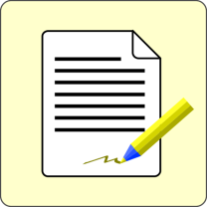
Writer: ___________________ Partner: _________________ Date: _____
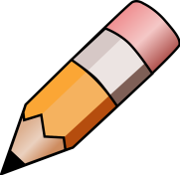
Editing Checklist

 | Yes I Did! | My Partner Agrees | I made  CORRECTIONS
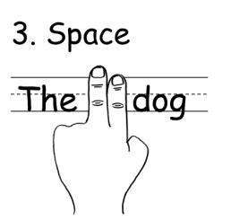
Used SPACES
between words

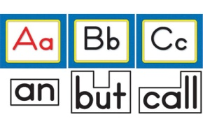
Spelled
SIGHT WORDS
correctly

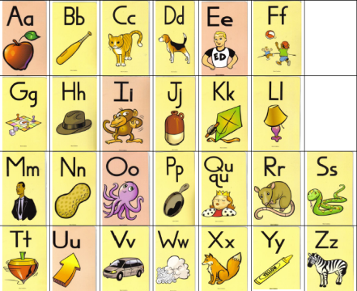
Used
LETTERS
and SOUNDS
to spell new words

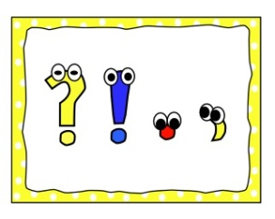
Used correct
PUNCTUATION
(periods, commas,
question marks,

We saw Mary at the store. Then I went home.
Used
CAPITALS
for names, I, and
at the beginning of a sentence

Formed
LETTERS
correctly

Can
READ
my own writing

